Tests of the strips of different sizes with the help of MIPs

Arrangement of strips inside of the counter (Rainer’s photo).

Top strip size 10х40х1300 mm³ with two WLS-fibers in a groove; it is cut out from extruded sheet of scintillator.

Strip in the middle is assembled of 12 pieces of injection molded scintillators 5х120х100 mm³. The full length of the strip is 1200 mm and thickness - 10 mm. For readout, we used six WLS- fibers in 6 grooves with 2 cm distance (steps) between them.

Bottom strip – it is collected from six pairs of injection molded scintillators 5х200х200 mm^{3 each}. The full length of the strip is 1200 mm and thickness - 10 mm. In this strip, we used 4 WLS-fibers in 4 grooves of each plate (thus 8 per strip).

Each strip was wrapped up with TYVEK paper.
BCF 91A DC types WLS-fibres with an Al reflector on far end from PMT were used.

Arrangement of the cartridge with strips on a bench (3 Photos.)

Used equipment: HV- source, Digital Voltmeter, LED-driver, an oscilloscope, trigger counters for muon selection.

Registration of signals and the analysis of data were made by means of OKA experiment DAQ system. The mode of a finding of coordinates of muon passage through a certain strip is tested.

After measurements in the beam, work on test of strips has been continued at the test bench with use of cosmic rays (see the scheme of Setup).

Strip 200x200

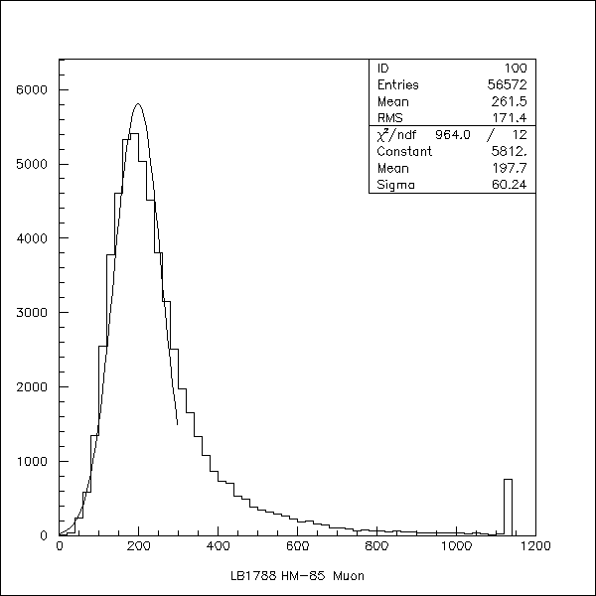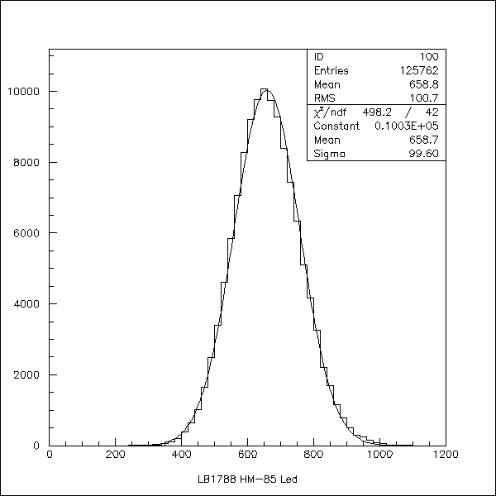

Strip 100x120

Mip signals for some PMT’s and Strip’s dimension at X=900mm.

PMT Type | Mean, chan | Sigma, chan | Nph el | (Nph el/Chanel)^-1
Strip 200x200
FEU-85 | 181.5 | 69.2 | 13.5 | 13.4
#LB 1788 | 197.7 | 60.2 | 13.1 | 15.0
#LB 3568 | 300.0 | 90.6 | 8.9 | 33.7
#LB 1743 | 164.8 | 51.5 | 13.6 | 12.1
#LB 2139 | 315.4 | 115.3 | 10.1 | 28.7
Strip 100x120
#LB 1788 | 121.7 | 51.5 | 8.2 | 14.8

Comparison QE of R7899 and QE FEU-85 for BCF 92 DC Emission

PMT Type | ## | QE R7899/QE FEU-85 | QE FEU-85 arb. un
FEU-85 | 1 |  | 1
# LB 1788 | 2 | 1.02
# LB 3568 | 3 | 0.66
# LB 1743 | 4 | 1.01
# LB 2139 | 5 | 0.81
# LB 3648 | 6 | 0.77
<Ham/FEU> | 7 | 0.85 |  | Mean
 |  | 0.16 |  | RMS
 |  | 0.19 |  | RMS/Mean

Comparison of the Light Yield of 120 and 200 mm strips width and extrapolation
Light Yield to variants: 2 WLS-fibers and 1 WLS-fiber per 4 cm width strip.

Transition from strips 200 and 120 mm to size 40mm

Strip 120/3 with 2 WLS-fibers

Strip 200/4 with 1 WLS-fiber

